**Data Flow Diagram**

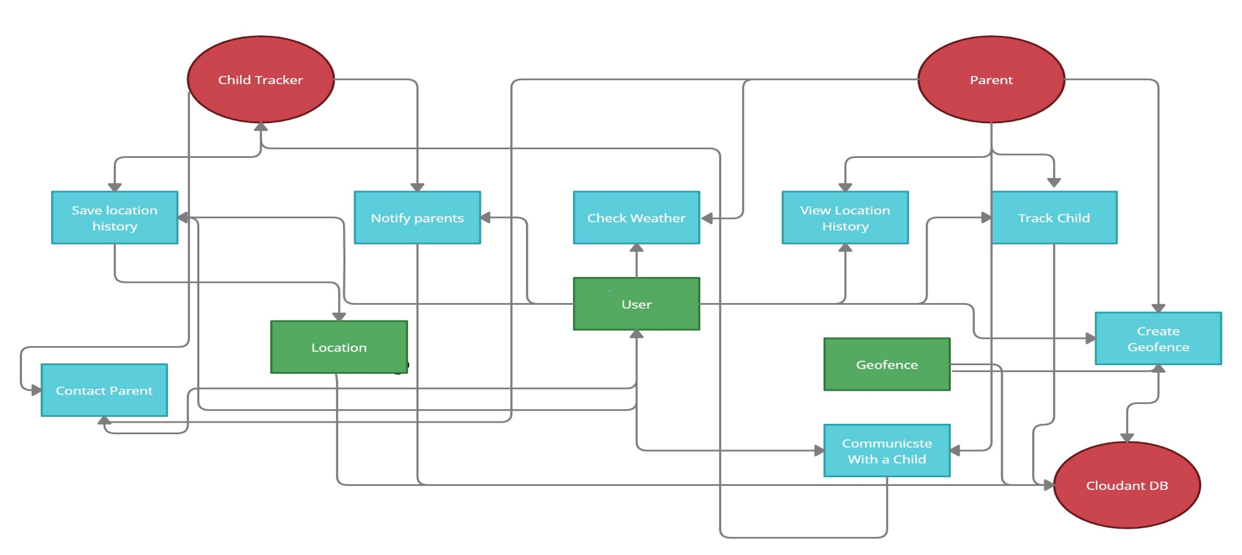Data Flow Diagram And user Stories

|  |  |
| --- | --- |
| Date | 04 November 2022 |
| Team ID | PNT2022TMID27152 |
| Project Name | Project - IoT Based Safety Gadget for Child Safety Monitoring & Notification |
| Maximum Marks | 4 Marks |

**User Stories**

|  |  |  |  |  |  |  |
| --- | --- | --- | --- | --- | --- | --- |
| Parent | Registration | USN-1 | As a user, I can register for the application by entering my email, password, and confirming my password. | I can access my account / dashboard | High | Sprint-1 |
|  |  | USN-2 | As a user, I will receive confirmation email once I have registered for the application | I can receive confirmation email & click confirm | High | Sprint-1 |
|  |  | USN-3 | As a user, I can register for the application through Gmail |  | Medium | Sprint-1 |
|  | Login | USN-4 | As a user, I can log into the application by entering email & password |  | High | Sprint-1 |
|  | Dashboard | USN-5 | As a user, I need to be able to view the functions that I can  perform |  | High | Sprint-1 |
| Child | Notification | USN-1 | As a user, I should be able to notify my parent in emergency  situations |  | High | Sprint-2 |
|  | Store data | USN-2 | As a user, I need to continuously store my location data into the db. |  | Medium | Sprint-2 |
|  | Communication | USN-3 | I should be able to communicate with my parents |  | Low | Sprint-3 |